Upper Yellowstone Watershed Group Drought Planning Factsheet

Definition of Drought
Drought is a complex climate phenomenon that impacts human and natural systems. Meteorological drought occurs when an area receives below normal precipitation for an extended time. Other types of drought occur when below-normal precipitation begins to impact water (hydrological drought), farms and ranches (agricultural drought), economies (socio-economic drought), and ecosystems (ecological drought).

Water Use
- The total population of park county is 15,972 (2015) with a water use of 284.4 million gallons (872 acre-feet) per day (2015)
- The population supported by the public water supply is 10,264 as of 2015 (from groundwater), and 5,482 are served by domestic wells.
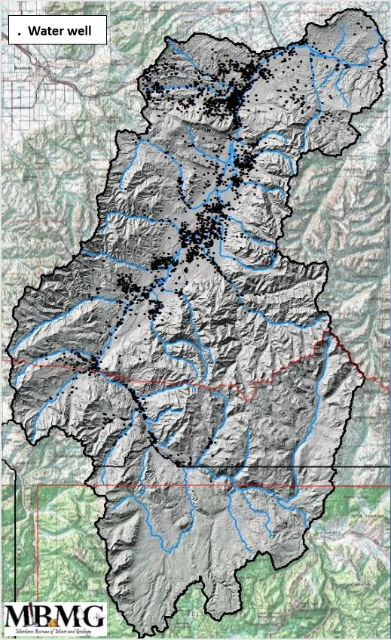
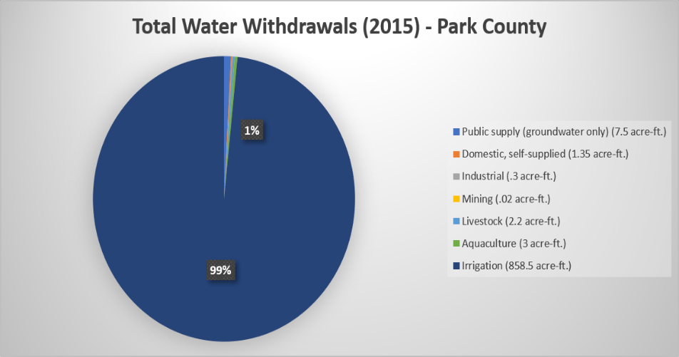
- Irrigation is the number one use of water in Park County, with public supply coming in second
LaFave 2019
Meloy 2019

Irrigation
- Nearly half of Park County (774,000 acres) is considered farmland that is primarily pasture (70%) with the remainder crops, woodland and other uses.
- In Park County, 61,470 acres (7%) are irrigated, with 68% sprinkler irrigation and 32% flood irrigation.
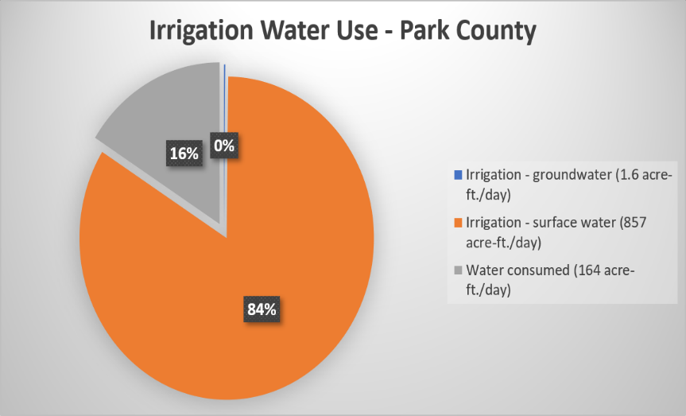
- Nearly all irrigation (99%) uses surface water. Of the 858 acre-feet withdrawn daily for irrigation, 84% returns to the hydrologic system and 16% is consumed by crops or evaporation. (shown in irrigation water use graphic)
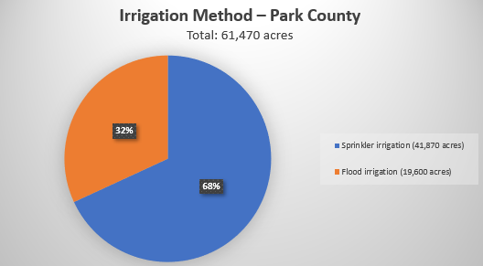
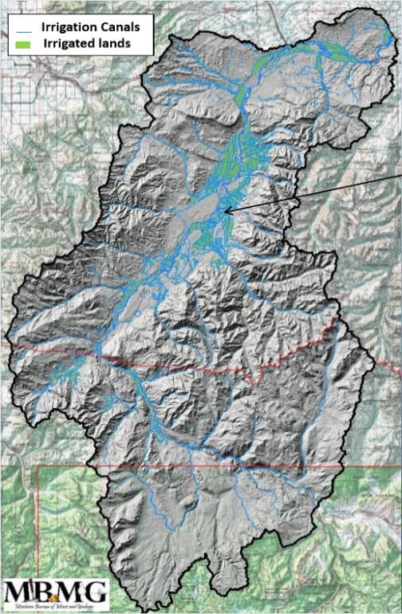
LaFave 2019
Meloy 2019

Meloy 2019

Groundwater and Yellowstone River Flow
- The Upper Yellowstone watershed’s intermountain basin is roughly one million acres with a valley floor one to eight miles wide framed by the Gallatin and Absaroka Ranges. This area is primarily glacial till and alluvial material in composition.
- The groundwater is stored and transmitted through basin fill and fractured rock aquifers.
- Groundwater can act as buffer to drought
- The Upper Yellowstone Watershed is a portion of the Missouri and Yellowstone Basin, the largest in the U.S. with more than 500,000 square miles. The Upper Yellowstone supplies the Basin with 46% of its surface water supply.
- The static water level in 5 monitored wells are not showing a depletion trend indicating groundwater withdrawals are small relative to recharge. Recharge is typically from canal seepage (incidental recharge), Mountain front stream loss, and from precipitation. Drought will reduce recharge to groundwater and increase withdrawals.
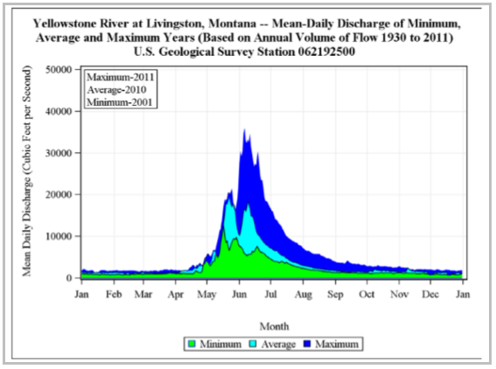
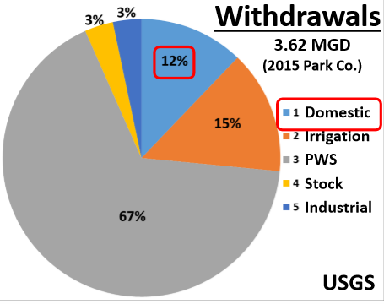
- Compared to data from 1950 base river flow is down 5% and the average August river flow is down 25%. Late season base flow has declined 25-35%.
LaFave 2018
LaFave 2019

Climate Change Impacts (Montana Climate Assessment – 2017)
- Groundwater demand is expected to increase with increasing temperature as well as changing seasonal availability of surface water.
- Snowpack has decreased, on average, 30% over the past several decades (1964-2017). Snowpack at mid-to-low elevation is thought to be most vulnerable to warming temperatures.
- Across Montana it is predicted that winter, spring and fall precipitation will increase while there is a decrease in summer precipitation, stressing water supply especially in summer and fall.
- Snowmelt and spring runoff are occurring 5-15 days earlier than historically. This trend is projected to continue, further limiting late summer water availability in snowmelt-dominated watersheds.
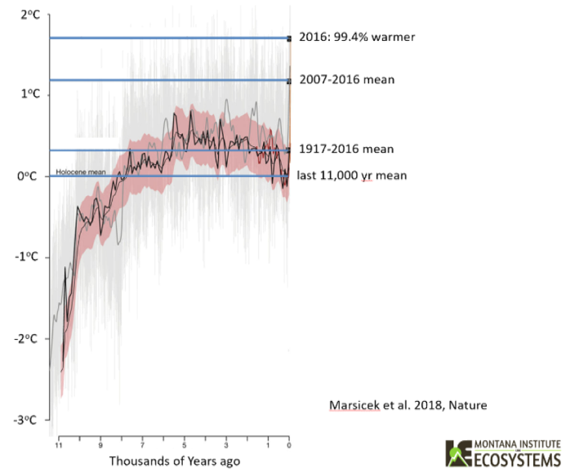
- Droughts are a natural feature of Montana’s climate and are projected to become longer and hotter due to increasing temperatures and changes in snowpack and runoff timing. (Note: Droughts may become increasingly hard to predict due to increasing variability in precipitation and warming temperatures)

Economic Value of the Yellowstone
- In Park County, $196 million in non-resident tourism revenue (2014) with $70 million a year directly form spending relating to the fishing industry, as well as 5-6 million coming from hunting in Park County. Increased water temperature may stress many important fish species imperative for the fishing industry.
- The Upper Yellowstone River is the most fished river in Montana is terms of angler days in Montana by both residents and non-residents.
- Of the tourist groups visiting Park County 12% had at least one member that fished bring in 128.6 million in revenue (2015). Comparatively, 8% of groups had at least one member that participated in rafting, floating, kayaking, or canoeing the river bringing in a revenue of $92 million to Park County.
- 4.1 million visitors to Yellowstone National Park (2015) which is a 13% increase since 2010.
- 31% of employment in Park County originates from tourism related industries (2014).
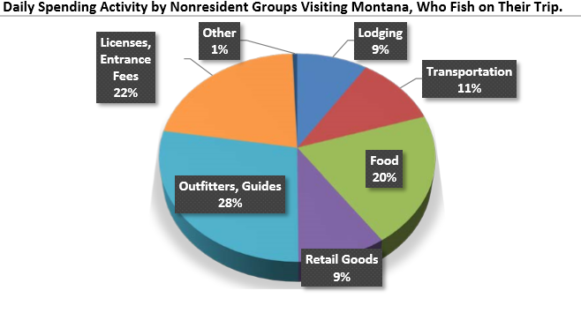
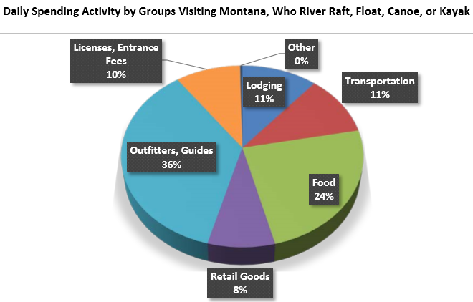
- The Upper Yellowstone River is the most fished river in Montana is terms of angler days in Montana by both residents and non-residents
Sage 2016
Sage 2016

References:
Dalby, C. (2018) Fluvial Geomorphology [PowerPoint slides]
LaFave, J. (2018) Basic hydrogeologic framework of Paradise Valley [PowerPoint slides]
LaFave, J. (2019) Domestic Wells and Groundwater – Upper Yellowstone Watershed [PowerPoint slides]
Marsicek, J., Shuman, B. N., Bartlein, P. J., Shafer, S. L., & Brewer, S. (2018). Reconciling divergent trends and millennial variations in Holocene temperatures. Nature, 554(7690), 92.
Meloy, S. (2019). Upper Yellowstone Drought Focus Group [PowerPoint slides]
Moorman, L. (2018) Land Use Trends in Paradise Valley [PowerPoint slides]
Sage, J. L. (2016). Economic Contributions of the Yellowstone River to Park County, Montana.
Swanson, L. (2018) Economic Profile of Park County [PowerPoint slides]
White, E. (2018) The Upper Yellowstone Headwaters [PowerPoint slides]
Whitlock, C. (2018) Montana Climate Trends and Water Supply [PowerPoint slides]
Whitlock, C., Cross, W. F., Maxwell, B. D., Silverman, N., & Wade, A. A. (2017). 2017 Montana Climate Assessment: Stakeholder driven, science informed (pp. 1-269). Montana Institute on Ecosystems.

